Challenges I faced:

1. When all the setting is done and we are ready for running docker command, I tried a docker build command ‘docker build -t docker-playground .’

but it throws an error

‘ERROR: Cannot connect to the Docker daemon at unix:///home/nafiz/.docker/desktop/docker.sock. Is the docker daemon running?’

Primary solution I found: Docker needs sudo permission.

Steps:
1. To make a docker images: ‘sudo docker build -t docker-playground .’
2. To run docker images: ‘sudo docker run docker-playground’
3. Then you login into docker in terminal: ‘sudo docker login’
4. To check all docker images: ‘sudo docker images’
5. To tag docker images: ‘sudo docker tag 4706daa52616 nafizzz85/docker-playground’
6. Now check again if the new docker image is created or not by step 4
7. To push docker images into docker hub: ‘sudo docker push nafizzz85/docker-playground’

Now to check docker image from different machine we can simply use https://labs.play-with-docker.com/ website.

Steps:
1. Login in https://labs.play-with-docker.com/ with docker id
2. You will get a machine ready for 4 just hours to check your docker image
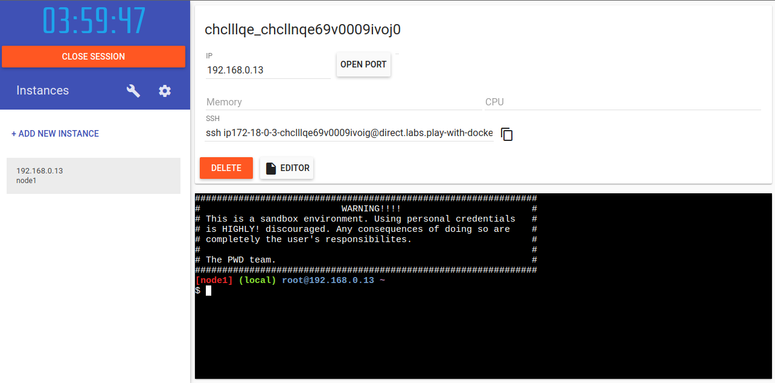
3. Check if there is node available in this machine or not by ‘node’
4. Check if there is docker installed
5. Now pull docker image into this machine by ‘docker pull nafizzz85/docker-playground’
6. Now run the image by ‘docker run nafizzz85/docker-playground’

